**Assignment 1: Application Packet**

**Hunter Black**

**ENGL 3153-009**

**18 Sept 2017**

**Assignment 1: Application Packet**

**Contents**

1. Curriculum Vitae…………………………………………………………………… 3
2. Resume Analysis…………………………………………………………………… 5
3. Job Calls / T-Charts………………………………………………………………… 9
4. Resume……………………………………………………………………………... 13
5. Cover Letter………………………………………………………………………... 14
6. Follow-Up Letter…………………………………………………………………... 15

**EDUCATION**

|  |  |
| --- | --- |
| Bachelors of Science, Computer Science  University of Oklahoma, Norman OK  GPA: 3.51 | May 2019 |

Relevant Coursework:

* Data Structures
  + Representation, analysis and implementation of data structures and associated algorithms including: algorithm complexity, sorting algorithms, lists, stacks, queues, search trees (AVL, Red-Black, Splay, 2-3), Heaps, Graphs, and Hashing
* Operating Systems
  + Includes activities to support understanding of both system programming and operating system theory
* Programming Structures & Abstractions
  + Further understanding of programming by introducing basic data structures, abstract classes, GUI, and MVC programming

Relevant Project(s):

* IMDB
* Worked in a rotating team of 4 to continually develop a mock IMDB-type program using Java and Eclipse
* Responsible for creating UML diagrams for each stage of development, as well as documenting code to allow other programmers to easily comprehend what each line of code was doing
* The program itself involved the creation of a sortable and searchable database system for varying types of objects, an interactive GUI using Java’s built in GUI system, and the implementation of an MVC model for said GUI

**EXPERIENCE**

|  |  |  |
| --- | --- | --- |
| Student Service Specialist | OU IT | October 2016 - Present |

* Communicate daily with customers in person, on the phone, and over email to help resolve any technical issues they are experiencing. Aid in resolving hardware and software related issues with customer’s devices, including virus mitigation, OS installs/wipes, software installation, and network troubleshooting. Resolve student/faculty account problems such as login issues, password resets, and new account creation.

|  |  |  |
| --- | --- | --- |
| Cashier/Cook/Shift Lead | Cafe Express | May 2012 - August 2015 |

* Took orders from customers, ran the expo, and performed restaurant cleanliness and maintenance duties such as sweeping/mopping, restocking, and bussing tables in the front of the house. Prepared food, cooked, and ran the dishwashing station in the back of the house. When scheduled as a shift lead, I delegated tasks to other employees and helped resolve customer complaints.

**TECHNICAL SKILLS**

Programming Languages/IDEs:

* Java, C++, C, C#, R
* Eclipse, Visual Studio, Xamarin Studio, R Studio

Software:

* Microsoft Office Suite, Cherwell, Slack, Unity

Operating Systems:

* Windows, Mac OS, Linux

**ACTIVITIES**

Big Event Operations Staff Member

* Corresponded with 5 potential job sites on a 2 person team to finalize the number of volunteers needed as well as other pertinent information such as food provision, weather contingency plans, tools needed for volunteers, and potential safety issues
* On the day of the event, oversaw distributing tools to designated teams in an efficient manner, as well as eventually heading out to a jobsite that had certain volunteers who did not show up

Dungeons & Dragons Club Worldbuilder

* Responsible for developing new, cohesive content for the collaborative world being built by the Worldbuilding Committee made up of 9 members
* Also in charge of collecting all created content and reformatting it into a more readable, user-friendly, and aesthetically pleasing format

Game Developer’s Association Member

* Worked with a team of 6 on creating the artwork, soundtrack, and code for a 2-D platforming game using the Unity Engine

Carroll Dragon Band Drum Major

* Responsible for leading a band comprised of 250 students along with 3 other drum majors in rehearsals, marching practices, football game halftime shows, and band competitions

GRACE Gala Organizer

* Organized and distributed over 300 invitations on a team of 2
* Aided with setup and breakdown of the gala itself on a team of 6

Greenhouse Construction Assistant

* Joined a team of 20 students to construct a small greenhouse using recycled plastic bottles and bamboo poles

**HONORS**

* Dick & Shirley O’Shields Engineering Scholarship
* Edna Neil Engineering Scholarship
* Honors College Member (Fall 2016 - Present)
* Oklahoma Award of Excellence 4-year scholarship
* Dean’s List (Fall 2015, Fall 2016, Spring 2017)

**Resume Analysis for Software Engineer**

Resume (images below): <https://www.linkedin.com/in/dvelkov/>

Analysis:

This resume belongs to Daniel Velkov, a software engineer working for Google. Immediately upon looking at this resume I notice Daniel’s experiences, listed reverse chronologically. Each of these experiences lists the dates during which they took place, as well as two to three short sentences detailing the responsibilities and projects that Daniel worked on. The formatting for each of these experience’s descriptions differs slightly, something that is to be avoided when creating a professional resume, as suggested in the “Resumes” PowerPoint. Although there are formatting differences, the amount of information presented and the type of information presented is relevant and pertinent to Daniel’s background and skills. He uses action words to describe what he did for each job/experience, something also suggested in the “Resumes” PowerPoint.

Underneath experience, Daniel lists education, which is short and to the point, listing where he received his bachelors and masters degrees from. He does omit his overall GPA, however this is most likely fine due to the fact that he has been working in the industry for almost ten years at this point. Employers are less likely to ask about college GPA after you acquire a certain amount of industry experience.

Finally, he lists all skills relevant to the industry that he works in, including programming languages and training. This allows employers to view hard skills that he possesses quickly to determine his qualifications for jobs that he applies for.

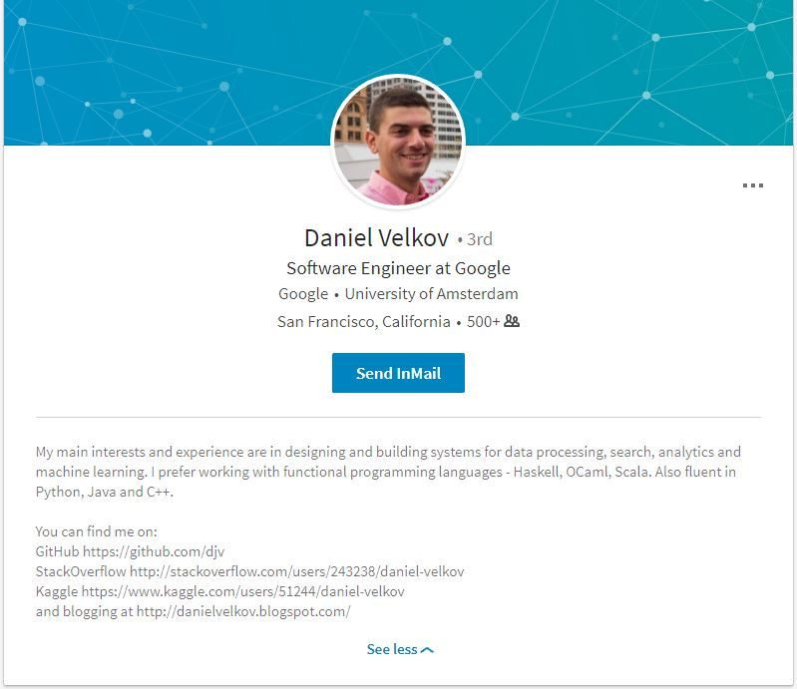

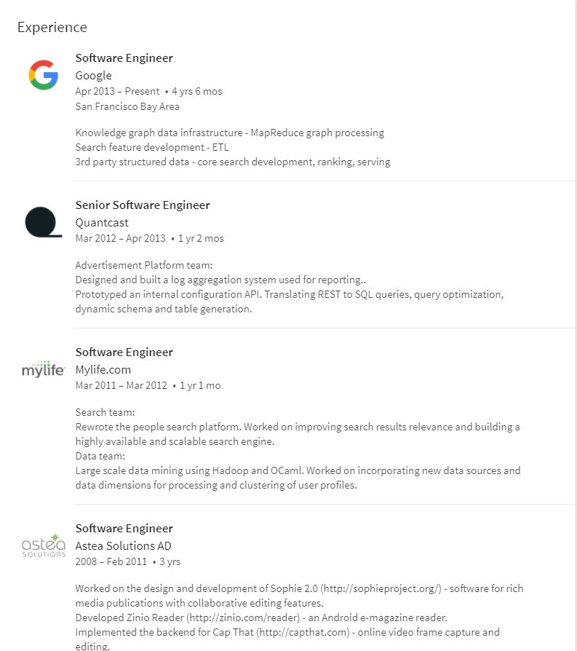

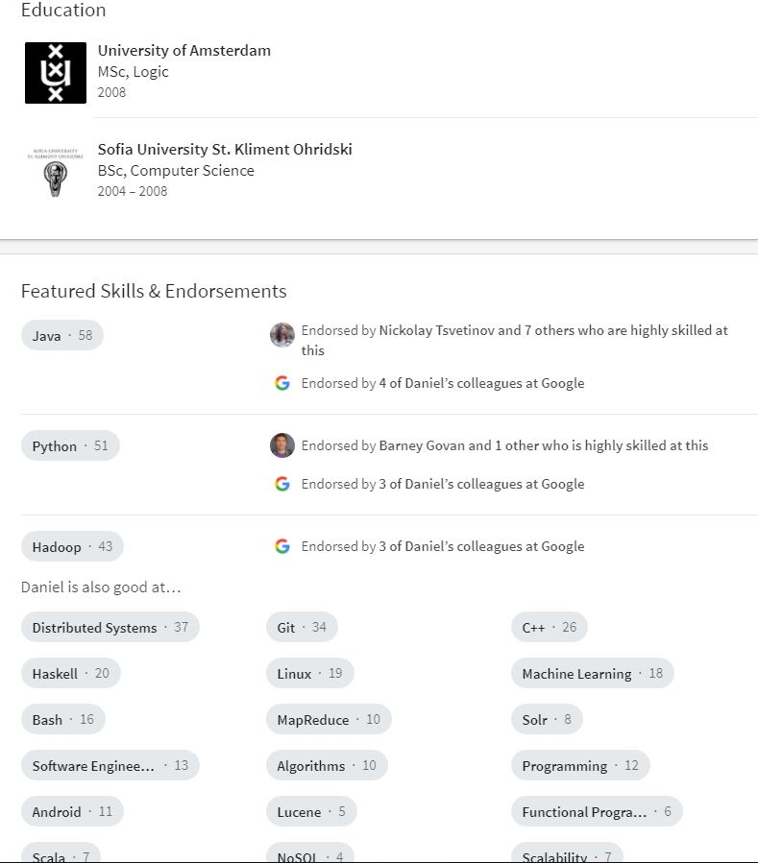

September 10, 2017

CrowdStrike

Dear ____,

I am writing to express interest in the position of Software Engineer. I have included a copy of my resume for your review. You will find that I have ample experience in OS knowledge of Windows, Mac OS, and Linux, solid experience in developing in C and C++, and several years of experience in interpersonal communication and collaboration.

Below is a comparison of your job requirements and my qualifications:

|  |  |
| --- | --- |
| Your Job Requirements | My Qualifications |
| * Can produce high quality software and can demonstrate that capability | Developed (independently and in teams) varying software projects through coursework, including the implementation of searching and memory management algorithms, as well as database creation and management |
| * Experience working on a team to ship major features and releases | Worked in rotating teams of 4 to develop and iterate on a working replica of an IMDB database system with a functional GUI using a MVC model of programming |
| * Able to communicate, collaborate, and work effectively in a distributed team | Collaborated with a team of roughly 60 people for the University of Oklahoma’s IT department to resolve technical issues experienced by members of the university, both hardware and software related |
| * Low-level OS knowledge in either Windows, Mac OS, or Linux | Working knowledge of Windows, Mac OS, and Linux on a low-level |
| * Flexible with working in user and kernel space and on multiple platforms | Worked on multiple different OS’s every day for school and work related issues, and thus comfortable with user space as well as kernel space |

I would welcome the opportunity to discuss your job requirements and my qualifications with you. I will contact you in a couple of days to follow up. Thank you for your consideration.

Sincerely,

Hunter Black

Job call analysis for CrowdStrike Software Engineer position:

CrowdStrike, a computer security company focused on understanding the goals, tactics, and techniques of attackers to prevent said attacks for their customers, is looking for a software engineer with a general understanding of the inner workings of operating systems, specifically kernel development on any platforms. They want their employees to implement this knowledge in developing cross-platform deliverables for their computer security products. This is a serious company that takes their customer’s personal information security to heart, and one that expects their employees to do the same.

To format my resume and cover letter to this job listing, I will emphasize my knowledge of operating systems and kernel development rather than focusing on other subjects that I am experienced with, thus connecting my hard skills with those catalogued from the job description as suggested in the “Beginning the Job Search: Locating & Analyzing Job Ads” PowerPoint. I will use the actions words listed in this job listing (communicate, collaborate, flexible, etc.) to align my resume with what CrowdStrike values. I will sound serious in my resume and cover letter, but also show my willingness to learn new techniques and skills in other areas than those which I am already familiar.

September 10, 2017

Dropbox

Dear___,

I am writing to express interest in the position of Software Engineer - Desktop Platform. I have included a copy of my resume for your review. You will find that I have ample experience in OS knowledge of Windows, Mac OS, and Linux, a solid understanding of software fundamentals, and several years of experience in team communication and collaboration.

Below is a comparison of your job requirements and my qualifications:

|  |  |
| --- | --- |
| Your Job Requirements | My Qualifications |
| * Strong engineering skills and software fundamentals | Developed (independently and in teams) varying software projects through coursework, including the implementation of searching and memory management algorithms, as well as database creation and management |
| * Ability to evaluate new and existing technologies and make recommendations for application improvement | Provide feedback daily to OU IT leads on how to improve the team’s use of information sharing technology like Slack, Cherwell, and PBWorks |
| * Eagerness to educate and collaborate with others | Collaborated with a team of roughly 60 people for the University of Oklahoma’s IT department to resolve technical issues experienced by members of the university, both hardware and software related |
| * Enthusiasm for creating features and infrastructure on all desktop operating systems | Working knowledge of Windows, Mac OS, and Linux, both low-level and high-level |
| * Expertise in Windows or OS X platforms with knowledge of system internals is a huge plus | Worked on multiple different OS’s every day for school and work related issues, and thus comfortable with user space as well as kernel space development |

I would welcome the opportunity to discuss your job requirements and my qualifications with you. I will contact you in a couple of days to follow up. Thank you for your consideration.

Sincerely,

Hunter Black

Job call analysis for Dropbox Software Engineer - Desktop Platform position:

Dropbox, one of the leading companies in cloud-based data storage, is looking for a software engineer to aid in building cross-platform desktop client features and infrastructure for their product, as well as to push the boundaries of OS integration, specifically on Mac and Windows. They are looking for someone with a working knowledge of the Windows and Mac OS and system internals who is willing collaborate in teams to evaluate existing technologies and develop new ones. Their culture is more casual than most, and is focused on fostering creativity and innovation.

To tailor my resume to this job listing, I will highlight my software engineering skills as well as my mastery of programming fundamentals. I will also feature my understanding of Windows, Mac OS, and Linux operating systems, both at a high-level and low-level, as these skills are listed as a “huge plus” by the employer. By highlighting skills that are not required but are preferred, I will stand out among other potential appliers. I will mimic the language used in the job listing in both my resume and cover letter, focusing on my desire to create new and innovative software solutions.

Compare/contrast of CrowdStrike and Dropbox job listings:

Both of these job listing are looking for a software engineer with a general understanding of programming principles and software fundamentals. Both do not require a degree in their job listings as requirements, but rather an eagerness to learn and a strong foundation to work from. CrowdStrike as a company comes across as more serious in their job listing, most likely due to the nature of the products that they produce, whereas Dropbox is more laid-back, focusing instead on culminating creativity and working on new and exciting solutions for their current products. Another interesting note of contention, the CrowdStrike job listing has a section for preferred requirements under their minimum requirements section, whereas the Dropbox listing only had one requirements section. This could prevent me from standing out immediately on paper if I were to apply to Dropbox, whereas if I were to apply to CrowdStrike I could highlight that I fulfill some of their preferred requirements, and thus setting myself apart from the rest of the applicants.

**EDUCATION**

|  |  |
| --- | --- |
| University of Oklahoma, Norman OK  Bachelors of Science, Computer Science  GPA: 3.51 | **May 2019** |

**Relevant Coursework:**

|  |  |
| --- | --- |
| * Programming Structures / Abstractions (Spring 2016) * Data Structures (Spring 2017) | * Intro to Operating Systems (Fall 2018) * Software Requirements & Specifications (Fall 2018) |

**Projects:**

|  |
| --- |
| * Iterated on an IMDB clone with rotating groups of 4 throughout a semester, implementing binary search for multiple different objects, Java GUI, and MVC design * Created C++ programs implementing home-made binary search trees, graphs, linked lists, and matrices |

**EXPERIENCE**

|  |  |
| --- | --- |
| **Student Service IT Specialist, University of Oklahoma** | **Oct 2016 - Present** |

* Communicate with customers through phone, email, and in person to help resolve both software and hardware based technical issues, including login errors, network troubleshooting, software installation, virus mitigation, and account creation / setup
* Collaborate closely with a team of roughly 60 people to pool knowledge and resources to get resolutions to customers as quickly as possible using Cherwell, Slack, and PBWorks

|  |  |
| --- | --- |
| **Cashier / Shift Lead, Cafe Express - Southlake, TX** | **May 2012 - Aug 2015** |

* Ensured customer satisfaction through taking orders, running expo, and resolving customer complaints about service or their meal
* Delegated tasks to other employees as a shift lead and managed basic restaurant functions

**ACTIVITIES**

|  |  |
| --- | --- |
| **Big Event Operations Staff - University of Oklahoma** | **Sept 2015 - Mar 2016** |

* Responsible for interviewing 6 job sites on a 2-person team to allocate volunteers and tools needed for the day of The Big Event
* Collaborated with a team of 40 to distribute tools to over 200 volunteer groups heading to roughly 160 jobsites, as well as volunteered at a jobsite who came up short in volunteers

**TECHNICAL SKILLS**

|  |  |
| --- | --- |
| **Programming Languages / IDEs & Design / OS / Software** |  |
| * Java, C / C++, C#, R * Windows, Mac OS X, Linux/Unix (Ubuntu) | * Eclipse, Visual Studio, Xamarin Studio, R Studio, Command Line, UML * Microsoft Office Suite, Slack, Cherwell |

Hunter Black

1528 Steamboat Way

Norman, OK, 73071

Phone: (817)-504-8660

Email: huntergblack@gmail.com

Dropbox

701 5th Ave

Seattle, WA, 98104

Dear HR Manager:

I was delighted to see the desktop platform software engineer position open up on your site. I have followed your company’s rise in the cloud-based technology sector, and have used your product throughout my time as a college student. I believe that my skills in multiple operating systems, both on a back-end and front-end level, as well as my 5 years of customer service experience will allow me to contribute to the rise in cross-platform integration and feature development for Dropbox in an effective and collaborative manner.

As a current student at the University of Oklahoma pursuing a bachelor’s in computer science, I have been exposed to key programming and software development fundamentals through coursework and projects. For example, through courses such as Data Structures I have developed skills in programming in Java, C++, and C by iterating on an IMDB clone which required the implementation of binary search trees and Java GUIs using MVC while working in rotating teams of 4. Additionally, through my Introduction to Operating Systems course, I grew accustomed to programming in the command line in Linux as well as furthered my understanding of operating system kernels and their role in how operating systems function. These skills will be an asset to the desktop platform aspect of Dropbox.

My time as an employee for the University of Oklahoma’s IT department has allowed me to hone my skills in interpersonal communication and teamwork. On a day-to-day basis, I am responsible for corresponding with my roughly 60 coworkers to resolve software and hardware based issues experienced by customers, all the while ensuring customer satisfaction. This will allow me to communicate clearly with members of your team both in person and through other mediums.

I have attached a copy of my resume which provides more information on my skills pertaining to this job. If you have any further questions, please don’t hesitate to reach out to me by either phone (817-504-8660) or through email (huntergblack@gmail.com). Thank you so much for your time, and I greatly look forward to hearing back from you.

Respectfully,

Hunter Black

September 11, 2017

Dear Mr. / Ms. Dropbox,

I want to express my thanks in meeting with you last Monday to discuss more about the software engineer position available at Dropbox. It was very insightful to tour the facility’s workspaces to get an idea of the day-to-day life of employees there.

As you noted in my interview, my training in both Windows and OS X operating systems through my time working with the University of Oklahoma’s IT department as well as through school projects from my Intro to Operating Systems course has set me up for success in developing cross-platform integration for Dropbox’s desktop app.

I look forward to investigating further the development process at Dropbox. I plan on delving deep into Dropbox’s public facing API to develop prototype apps for productivity and security, which I will be excited to share with you when I hear back.

Thank you again for interviewing me for the position and for your generous hospitality. Please let me know if you have any other questions or if there is anything else that I can provide for you to make your decision easier. I look forward to hearing from you.

Respectfully yours,

Hunter Black